COMENIUS PROJECT
Technologic area proposal

The structure of this proposal consider the resources and not the ages. It means that all these suggestions could be used wherever were applicable.

WEB RESOURCES

Web pages to develop and deep in technology matters: spreading information, problems, simulations, games, etc. Some exemples:

- General contents

http://www.tecno12-18.com/
http://www.xtec.es/aulanet/ud/
http://www.xtec.net/~jrosell3/
http://www.asifunciona.com/asi_funciona.htm

- Specific contents

http://www.maquelec.net/
http://www.iesalquibla.com/TecnoWeb/estructuras/estructura_index.htm
http://www.maloka.org/f2000/lasers/
http://fluidos.eia.edu.co/fluidos/clepsidra/clepsidra.html
http://www.xtec.es/~ccapell/web_master/index_clasic.htm

OFFICE

- Word: For all kind of works getting a formal presentation: reports, projects, etc.

- Excel: Using spreadsheets and generalizing calculation problems. For example (fluids mechanics):

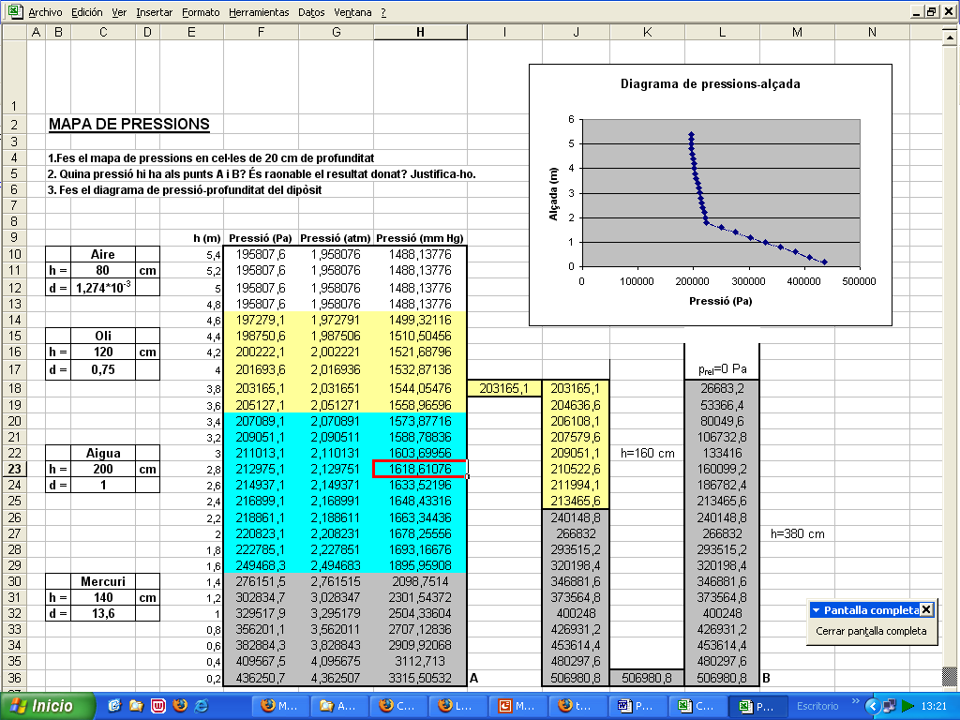

- PowerPoint: Developing formal presentations.

- Access: Using a data base in order to control a stocks management, a library, and all kind of data.

OTHER PROGRAMS

- Graphic Editors (AutoSketch, Home 3D Design, Wings 3D)

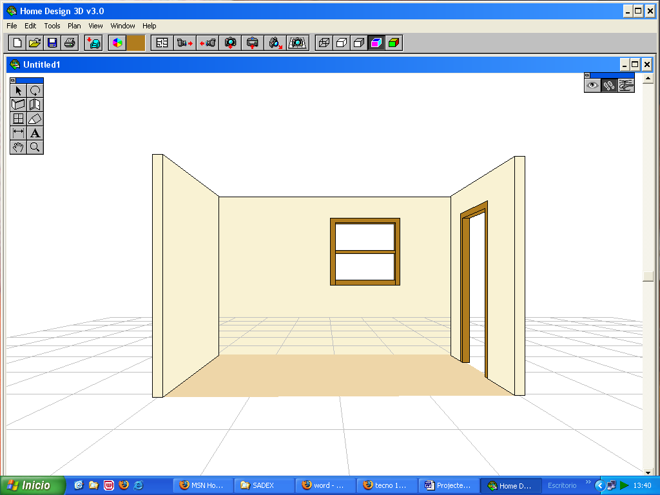
- Mechanics Software (Mecanismos, Beams, Palanca, Relatran, Interactive Physics)

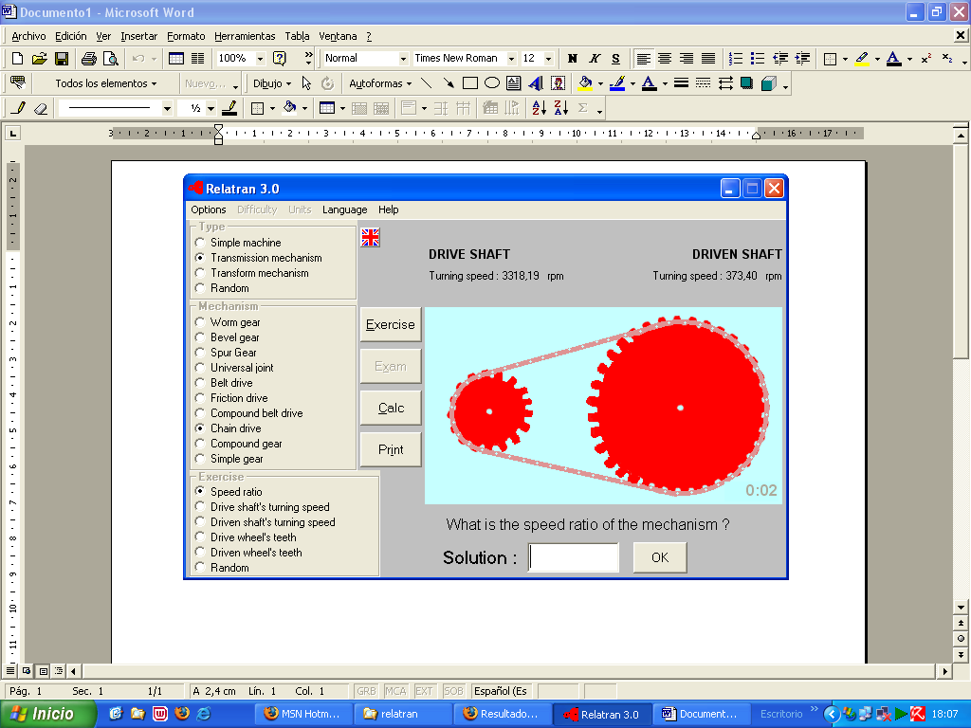

- Elect. Software (Digital simulator, EWB, Crocodile Clips 3 Elementary)

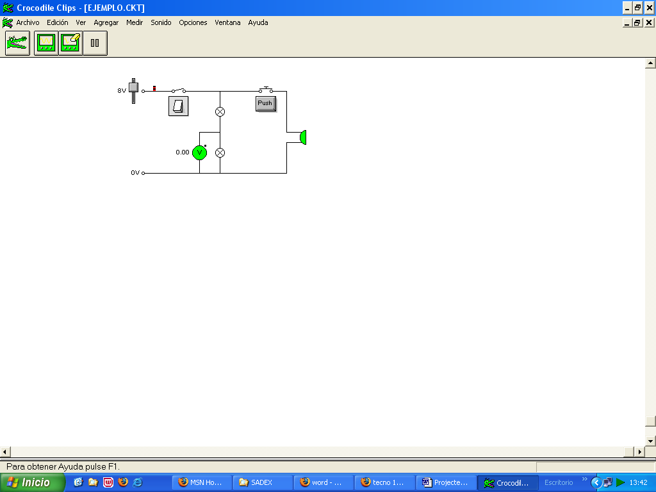
- Web Design Editors (Dreamweaver, FrontPage)

- Others (Pneusim, SmartDraw7)

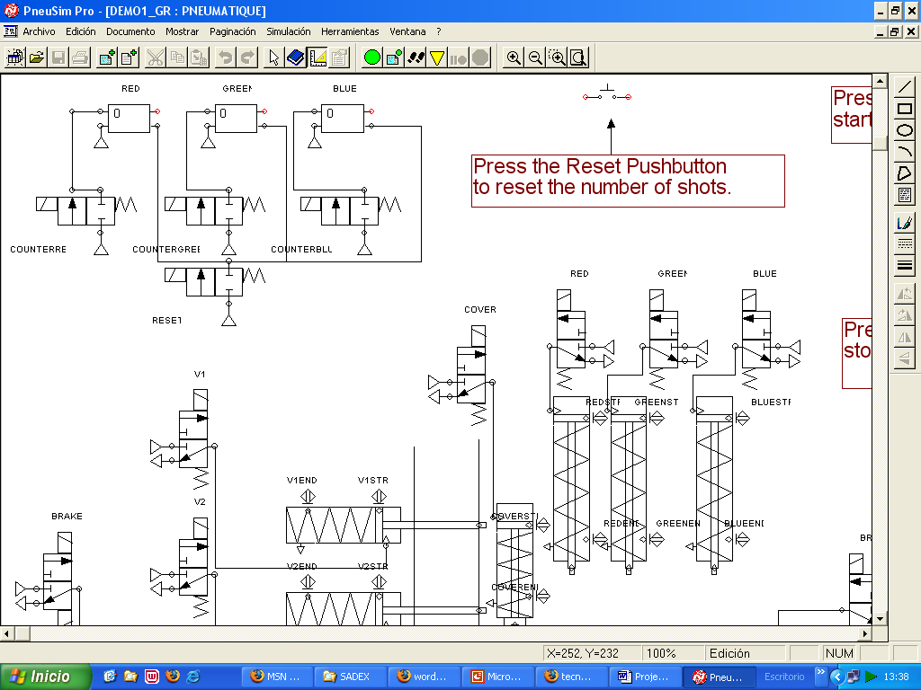

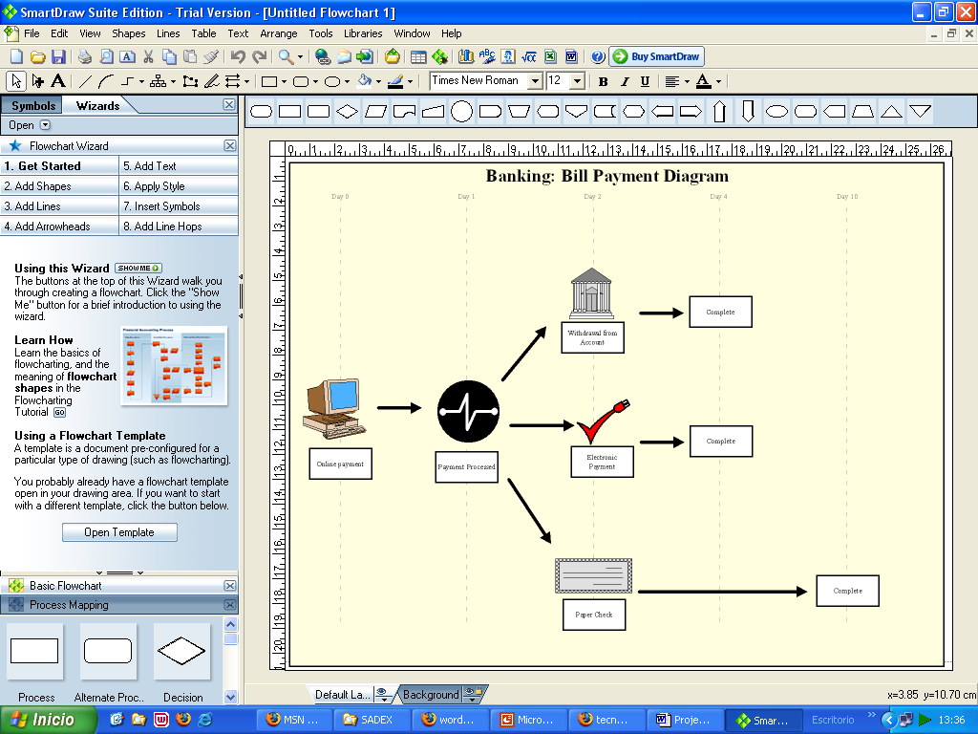

OTHERS

- Numerical control in a Machine tool (Engine Lathe)

- Data Receptor System: Sadex System and its software (Sadex Control and Itera)

